https://shorturl.at/G2IAP 18 Dec 2024

G17 BEE
KickStart with Node.js https://shorturl.at/6DjNO
Creating endpoints
Handling exceptions
Task :- Custom Navigation

handling exceptions(errors)
- There are various ways in node.js to handle the exceptions
- Synchronous errors: Use try-catch blocks to handle exceptions.
- Asynchronous errors: Handle errors in callbacks by checking the first argument (err).
- Global errors: Use process.on('uncaughtException') to handle uncaught exceptions globally.
- Custom errors: You can create custom error objects using Error and manipulate their properties.

Creating endpoints
- method is the predefined key from req object.
- this key gives type of method in request.
- url is the predefined key from req object.
- this key gives url of the request.
- setHeader is the predefined function from res object
- this function is used to set headers.
- statusCode is the predefined key from res object.
- we can set status code using this key.
- handleError is the user defined function.
- we are handling exceptions(errors) from this function.
- possible errors are
- 'Route not found'
- 'Invalid method'
- etc
- if any error occurred statusCode will be 4xx.

//Import the 'http' module
const http = require('http')

//handle the errors
function handleError(res, errorCode, message) {
res.statusCode = errorCode
res.write(message)
res.end()
}

// Create HTTP server
const server = http.createServer((req, res) => {
// Set the response header indicating the content type is JSON
res.setHeader('Content-Type', 'application/json')
res.statusCode = 200
//GET method
if (req.method == 'GET') {
if (req.url == '/')
res.write('Default get request')
else if (req.url == '/login')
res.write('Login get request')
else
handleError(res, 404, 'Route not found')
}
//POST method
else if (req.method == 'POST') {
if (req.url == '/')
res.write('Default post request')
else if (req.url == '/login')
res.write('Login post request')
else
handleError(res, 404, 'Route not found')
}
else
handleError(res, 404, 'Invalid Method')
res.end()
})

// Start the server on port 8080
const PORT = 8080
server.listen(PORT, () => {
console.log(`Server is running at http://localhost:${PORT}`)
})

Test in Postman
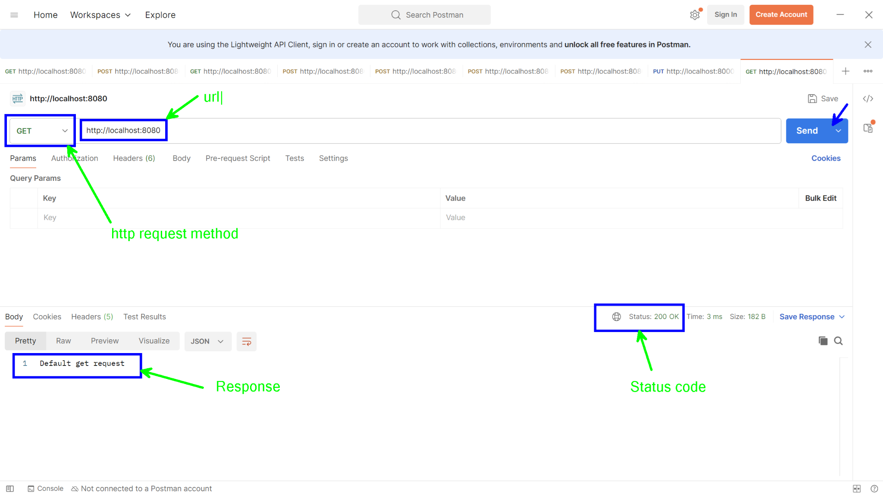

Task:-
Create nodeserver
Display home page
on home page provide two links/buttons
login and dashboard
dashboard -> error route not found
on login navigate to login endpoint -> login get request
on login page accept username and password
as per authentication display respective messages
apply proper styling

//Import the 'http' and 'querystring' modules
const http = require('http')
const qs = require('querystring')

// handle the errors
function handleError(res, errorCode, message) {
res.statusCode = errorCode
res.write(message)
res.end()
}

// Create HTTP server
const server = http.createServer((req, res) => {
// Set the response header
res.setHeader('Content-Type', 'text/html')
res.statusCode = 200

// Log the incoming request to see headers
console.log(`Request method: ${req.method} | URL: ${req.url}`)

//GET method
if (req.method == 'GET') {
if (req.url == '/') {
res.write(homePage)
}
else if (req.url == '/login') {
res.write(loginPage)
}
else {
handleError(res, 404, 'Route not found')
}
}
// POST method
else if (req.method == 'POST') {
if (req.url == '/') {
res.write('Default post request')
}
else if (req.url == '/login') {
let body = ''

// Listen to post parameters
req.on('data', (data) => {
body += data
})

// end callback to node engine
req.on('end', () => {
// Log the body to see what data is being received
console.log('Received Body:', body)

// Parse the form data
let obj = qs.parse(body)
console.log('Parsed Object:', obj) // Check if we are parsing correctly

// Extract username and password
let uname = obj.uname
let upwd = obj.upwd

// Basic validation
if (uname === 'admin' && upwd === 'admin') {
res.write("<h1 style='color:green'> Login Success </h1>")
} else {
res.write("<h1 style='color:red'> Login Failed </h1>")
}
res.end()
})

} else {
handleError(res, 404, 'Route not found')
}
}
else {
handleError(res, 404, 'Invalid Method')
}
})

// Start the server on port 8080
const PORT = 8081
server.listen(PORT, () => {
console.log(`Server is running at http://localhost:${PORT}`)
})

// Home Page HTML
let homePage = `<!DOCTYPE html>
<html lang="en">
<head>
<meta charset="UTF-8">
<meta name="viewport" content="width=device-width, initial-scale=1.0">
<link href="https://cdn.jsdelivr.net/npm/bootstrap@5.3.0-alpha1/dist/css/bootstrap.min.css" rel="stylesheet">
<title>Home Page</title>
</head>
<body class="bg-light">
<nav class="navbar navbar-expand-lg navbar-light bg-primary">
<div class="container-fluid">
<a class="navbar-brand text-white" href="#">Home</a>
<button class="navbar-toggler" type="button" data-bs-toggle="collapse" data-bs-target="#navbarNav" aria-controls="navbarNav" aria-expanded="false" aria-label="Toggle navigation">
<span class="navbar-toggler-icon"></span>
</button>
<div class="collapse navbar-collapse" id="navbarNav">
<ul class="navbar-nav ms-auto">
<li class="nav-item">
<a class="nav-link text-white" href="/login">Login</a>
</li>
<li class="nav-item">
<a class="nav-link text-white" href="/dashboard">Dashboard</a>
</li>
</ul>
</div>
</div>
</nav>
<div class="container text-center my-5">
<h1 class="display-4 text-primary mb-4">Welcome to Home</h1>
<p class="lead">Please choose an action below:</p>
<div>
<a href="/login" class="btn btn-primary btn-lg mx-3">Login</a>
<a href="/dashboard" class="btn btn-secondary btn-lg mx-3">Dashboard</a>
</div>
</div>
<script src="https://cdn.jsdelivr.net/npm/@popperjs/core@2.11.6/dist/umd/popper.min.js"></script>
<script src="https://cdn.jsdelivr.net/npm/bootstrap@5.3.0-alpha1/dist/js/bootstrap.min.js"></script>
</body>
</html>`

// Login Page HTML (same as before)
let loginPage = `
<!DOCTYPE html>
<html>
<head>
<style>
h1 {
color: white;
text-transform: uppercase;
font-weight: normal;
}
body {
background: radial-gradient(white, black);
font-family: sans-serif;
}
.box {
background-color: black;
width: 300px;
margin: 50px auto;
padding: 40px;
border-radius: 20px;
text-align: center;
}
input {
margin: 20px auto;
text-align: center;
padding: 14px 10px;
width: 200px;
border-radius: 24px;
background: none;
}
input[type="text"],
input[type="password"] {
border: 2px solid skyblue;
color: lightyellow;
}
input[type="submit"] {
border: 2px solid burlywood;
color: white;
cursor: pointer;
}
</style>
</head>
<body>
<form action="/login" method="post" class="box">
<h1>Login Page</h1>
<input type="text" placeholder="Username" name="uname" required>
<input type="password" placeholder="Password" name="upwd" required>
<input type="submit" value="Login">
</form>
</body>
</html>`

